**PREDICTING PERSONAL LOAN APPROVAL USING MACHNE LEARNING**

**1.INTRODUCTION**

Finance companies deal with all kinds of loans such as house loans, vehicle loans, educational loans, personal loans etc... And has a presence across areas such as cities, towns and village areas. A Customer- first requests for a loan and after that Finance Company validates the customer eligibility for the loan and of approve. Details like marital status, gender, education, and number of dependents, Income, Loan Amount, credit history, and others are given in the form to fill up by the applicants. Therefore, a robust model is built taking those details as input to verify whether an applicant is eligible to apply for loan or not. The target variable here is Applicants "Loan Status" and the other variables are predictors. After building the Machine Learning model a Web Application is to be developed for a user interface that allows the user to see instantly if he/she is eligible to get a loan by entering the given details.

A loan is the core business part of banks. The main portion the bank’s profit is directly come from the profit earned from the loans. Though bank approves loan after a regress process of verification and testimonial but still there’s no surety whether the chosen hopeful is the right hopeful or not. This process takes fresh time while doing it manually. We can prophesy whether that particular hopeful is safe or not and the whole process of testimonial is automated by machine literacy style. Loan prognostic is really helpful for retainer of banks as well as for the hopeful also.

A loan is a sum of money that is borrowed and repaid over a period of time, typically with interest. There are various types of loans available to individuals and businesses, such as personal loans, mortgages, auto loans, student loans, business loans and many more. They are offered by banks, credit unions, and other financial institutions, and the terms of the loan, such as interest rate, repayment period, and fees, vary depending on the lender and the type of loan

**1.1 OVERVIEW**

Banking are making major part of profits through loans. Though lot of people are applying for loans. It’s hard to select the genuine applicant, who will repay the loan. While doing the process manually, lot of misconception may happen to select the genuine applicant. Therefore we are developing loan prediction system using machine learning, so the system automatically selects the eligible candidates. This is helpful to both bank staff and applicant. The time period for the sanction of loan will be drastically reduced. In this project we are predicting the loan data by using machine learning.

A personal loan is a type of unsecured loan that can be used for a variety of expenses such as home repairs, medical expenses, debt consolidation, and more. The loan amount, interest rate, and repayment period vary depending on the lender and the borrower's creditworthiness. To qualify for a personal loan, borrowers typically need to provide proof of income and have a good credit score.

**1.2 PURPOSE**

It is done by predicting if the loan can be given to that person on the basis of various parameters like credit score, income, age, marital status, gender, etc. The prediction model not only helps the applicant but also helps the bank by minimizing the risk and reducing the number of defaulters.

Predicting personal loan approval using machine learning analyses a borrower's financial data and credit history to determine the likelihood of loan approval. This can help financial institutions to make more informed decisions about which loan applications to approve and which to deny.

**2. PROBLEM DEFINITION & DESIGN THINKING**

**2.1. EMPATHY MAP**

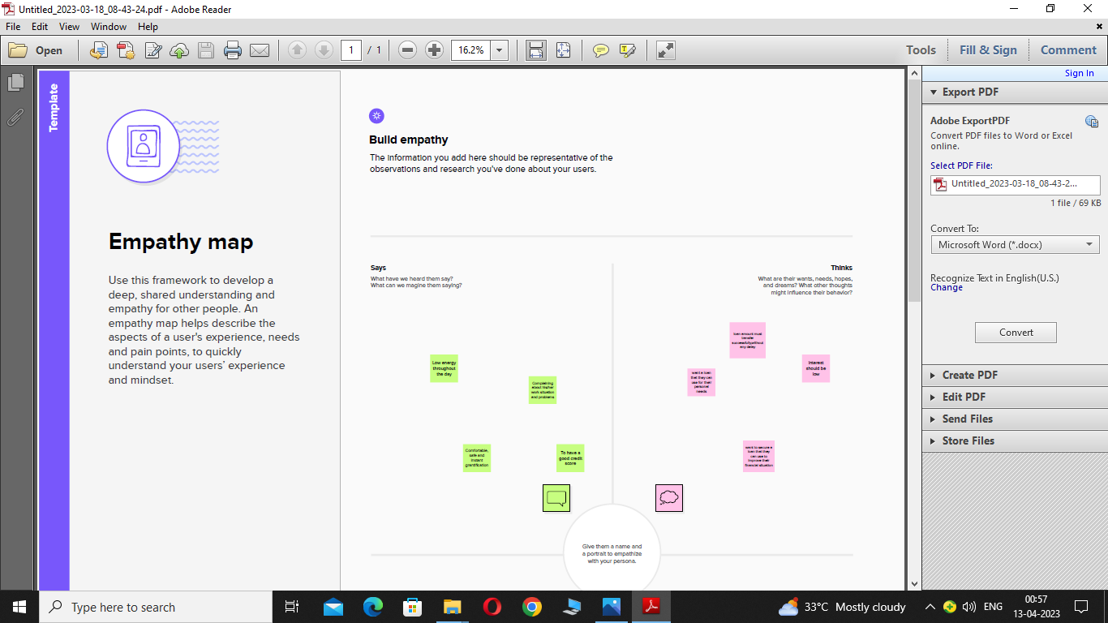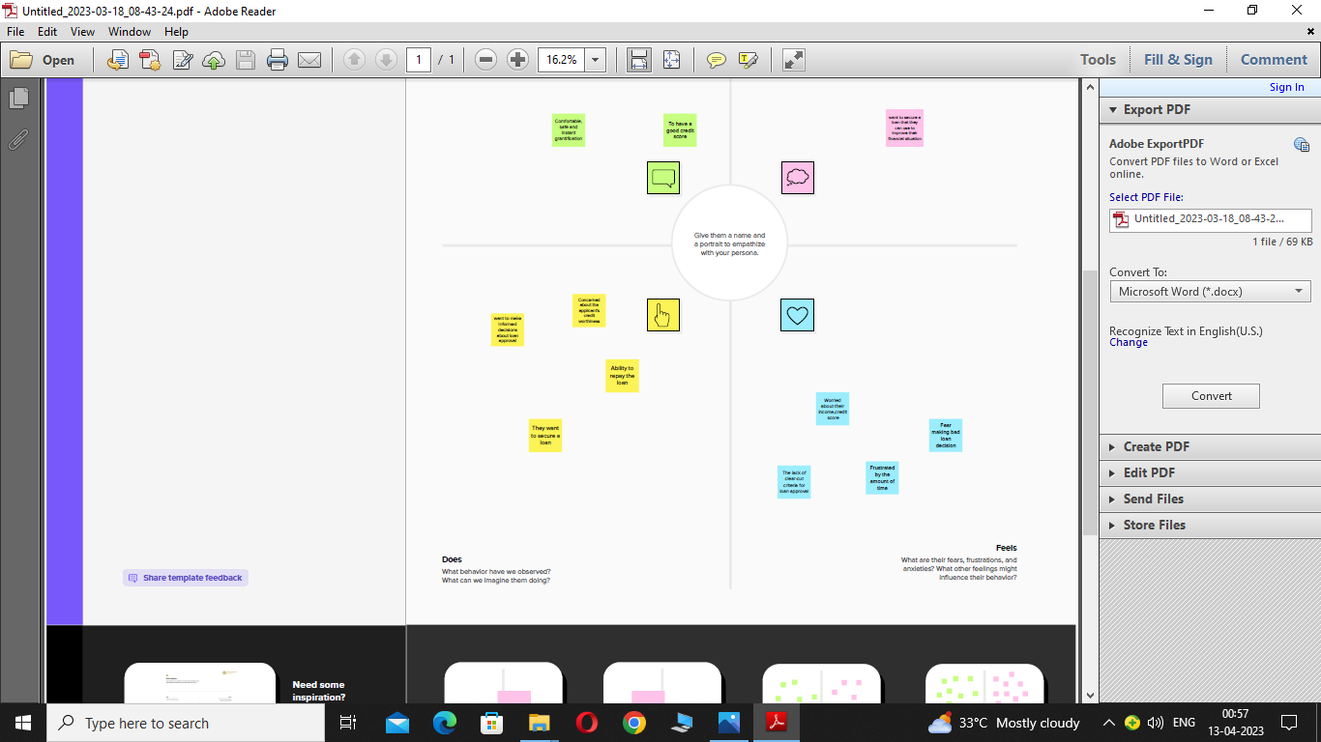

**2.2 IDEATION & BRAINSTORMING MAP**

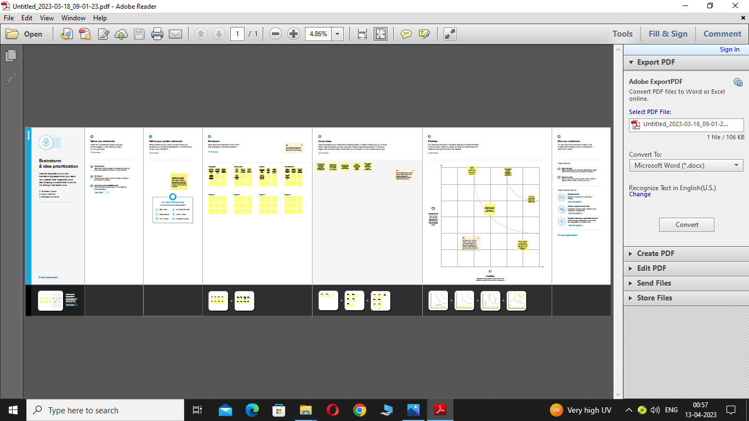

**4. ADVANTAGES & DISADVANTAGES**

**ADVANTAGES**

* It is done by predicting if the loan can be given to that person on the basis of various parameters like credit score, income, age, marital status, gender, etc.
* The prediction model not only helps the applicant but also **helps the bank by minimizing the risk and reducing the number of defaulters**.
* A bank loans money to a business based on the value of the business and its perceived ability to service the loan by making payments on time and in full. Unlike with equity finance where the business issues shares, banks do not take any ownership position in businesses.
* Bank personnel also do not get involved in any aspect of running a business to which a bank grants a loan. This means you get to retain full management and control of your business with no external interference.
* Once a business borrower has paid off a loan, there is no more obligation to or involvement with the bank lender unless the borrower wishes to take out a subsequent loan. Compare this with equity finance, where the company may be paying out dividends to shareholders for as along as the business exists
* The interest on business bank loans is tax-deductible.
* In addition, especially with fixed-rate loans, in which the interest rate does not change during the course of a loan, loan servicing payments remain the same throughout the life of the loan.
* This makes it easy for businesses to budget and plan for monthly loan payments. Even if the loan is an adjustable-rate loan, business owners can use a simple spreadsheet to compute future payments in the event of a change in rates.

**DISADVANTAGES**

* One of the greatest disadvantages to bank loans is that they are very difficult to obtain unless a small business has a substantial track record or valuable collateral such as real estate.
* Banks are careful to lend only to businesses that can clearly repay their loans, and they also make sure that they are able to cover losses in the event of default.
* Business borrowers can be required to provide personal guarantees, which means the borrower's personal assets can be seized in the event the business fails and is unable to repay all or part of a loan.
* Interest rates for small-business loans from banks can be quite high, and the amount of bank funding for which a business qualifies is often not sufficient to completely meet its needs.
* The high interest rate for the funding a business does receive often stunts its expansion, because the business needs to not only service the loan but also deal with additional funding to cover funds not provided by the bank.
* Loans guaranteed by the U.S. Small Business Administration offer better terms than other loans, but the requirements to qualify for these subsidized bank loans are very strict.

**5. APPLICATIONS**

* Machine learning has become increasingly popular in the finance industry, particularly in predicting personal loan approval. Here are some applications for predicting personal loan approval using machine learning:
* Credit Scoring: One of the most common applications of machine learning in finance is credit scoring. Credit scores are used by lenders to assess the creditworthiness of borrowers, and machine learning algorithms can help predict the likelihood of loan repayment based on various factors such as income, employment history, credit history, and loan purpose.
* Risk Assessment: Machine learning can be used to analyze a variety of data points and identify patterns that may indicate a high or low risk of default. For example, data on past delinquencies, credit history, employment status, and other factors can be used to predict whether a borrower is likely to default on their loan.
* Fraud Detection: Machine learning can be used to detect fraudulent loan applications by analyzing patterns and identifying anomalies in the data. This can help lenders avoid losses and protect themselves against fraudulent activities.
* Loan Recommendation: Machine learning algorithms can analyze data on customer preferences and behaviors to recommend loan products that are tailored to their needs. This can help lenders increase their customer base and improve customer satisfaction.
* Automated Underwriting: Machine learning can also be used to automate the underwriting process, allowing lenders to quickly and accurately assess loan applications and make decisions based on data-driven insights.
* Overall, machine learning can provide valuable insights for lenders in predicting personal loan approval, and help them make more informed decisions.

**6. CONCLUSION**

* Dataset from a Lending club is an interesting dataset. It is offen very difficult to get the insights of interest rate from Bank. This analysis provides interesting information about the interest rate which we get from Lending club for each person.
* The interest rate which we receive depends on the various factors like FICO score, Homeownership, Purpose of loan, Team length of loan, loan amount requested, Annual income, Employee length, Issue month, Previous bankrupcies and Debt to income ratio.
* If a person is wanting to get a good interest rate then he need to focus on above factors before applying for a lending club loan.
* From the research question, I understood that we need to perform various test and add visalizations to understand the patern of Lending club borrowers data and find the interest rate. It is not a very straight forward method which gets from FICO scores. Also lot of financial terms while dealing with loans.
* Therefore, the developed model automates the method of determining the applicant's creditworthiness.
* It focuses on information containing the main points of the loan applicants. In this system NAIVE BAYES Classification model is used.
* In Machine Learning, NAIVE BAYES classification analysis is one of the supervised learning algorithms, which is dependent on BAYES theorem and used to solve classification problems.
* Hence, it is good for predicting the right result in the current world scenario and also help the bank to give the money in the right hands and also help the people in getting loan in a much faster way. The main advantage of this system is, it gives more accuracy.

**7. FUTURE SCOPE**

* In future, this model can be used to compare various machine learning algorithm generated prediction models and the model which will give higher accuracy will be chosen as the prediction model.
* This Project Work Can Be Extended To Higher Level In Future.
* For Example, A Predictive Model For Loans That Uses Machine Learning Algorithms, Where The Results From Each Graph Of The Project Can Be Taken As Individual Criteria For The Machine Learning Algorithm Can Be Created. Also, A Risk Score Can Be Generated Based On Applicant To Predict Loan Default Rate.

**8. APPENDIX**

1. **SOURCE CODE**



